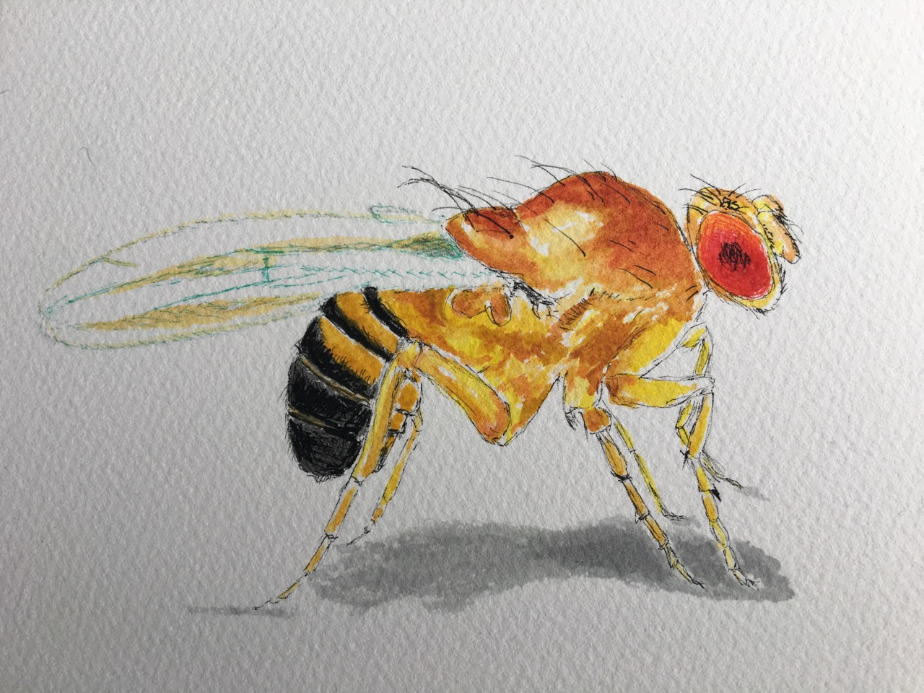

DROSOPHILA Ink and watercolor on paper, 6 x 4 inches

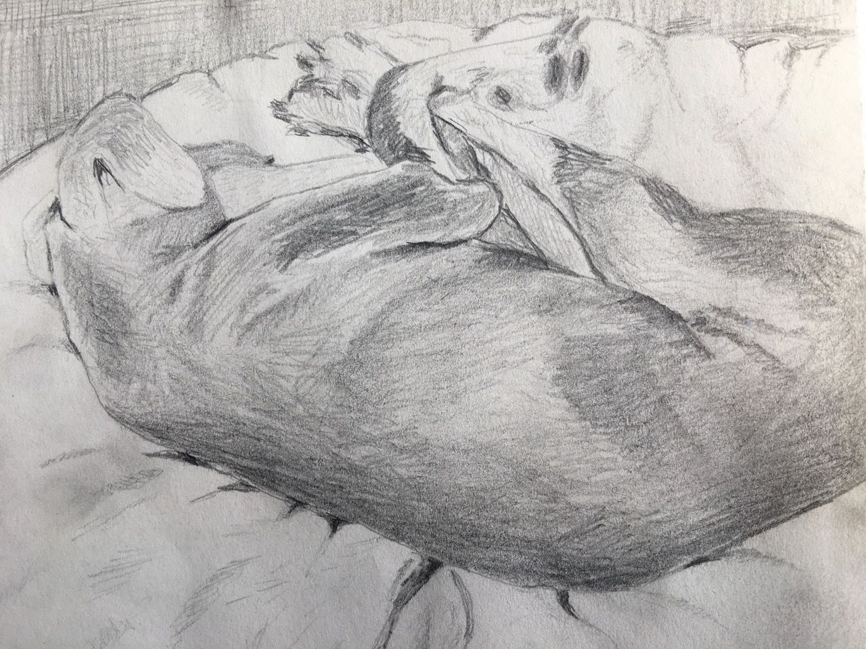

PIPPI Pencil paper, 6 x 4 inches

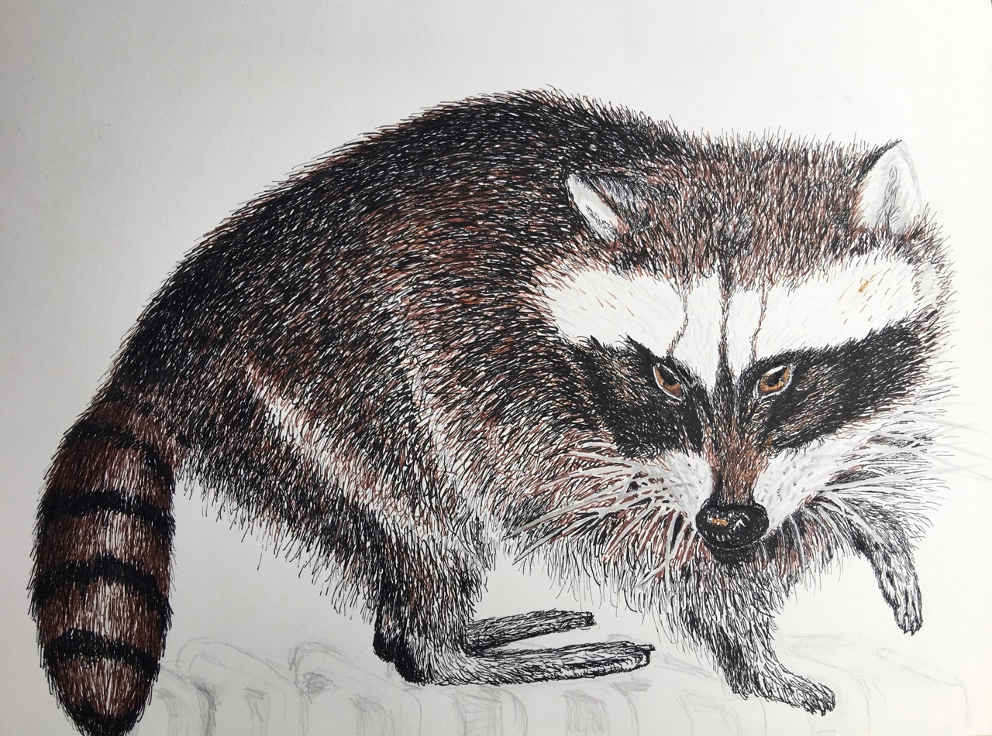

RACCOON Ink on paper, 10 x 8 inches

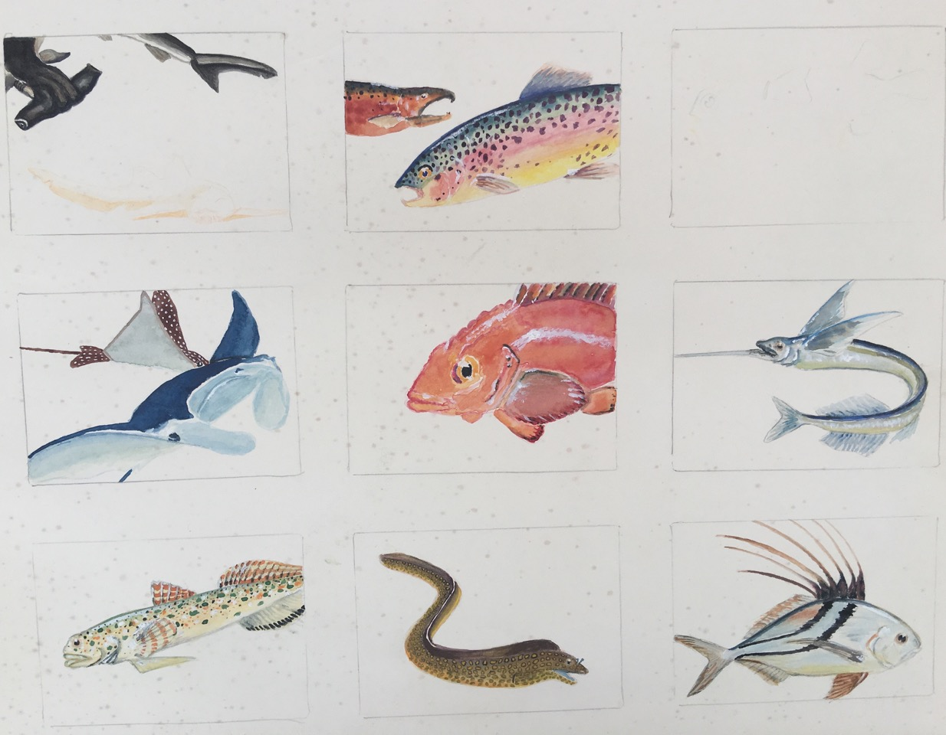

SEA CREATURES Acrylic on paper, 24 x 20 inches

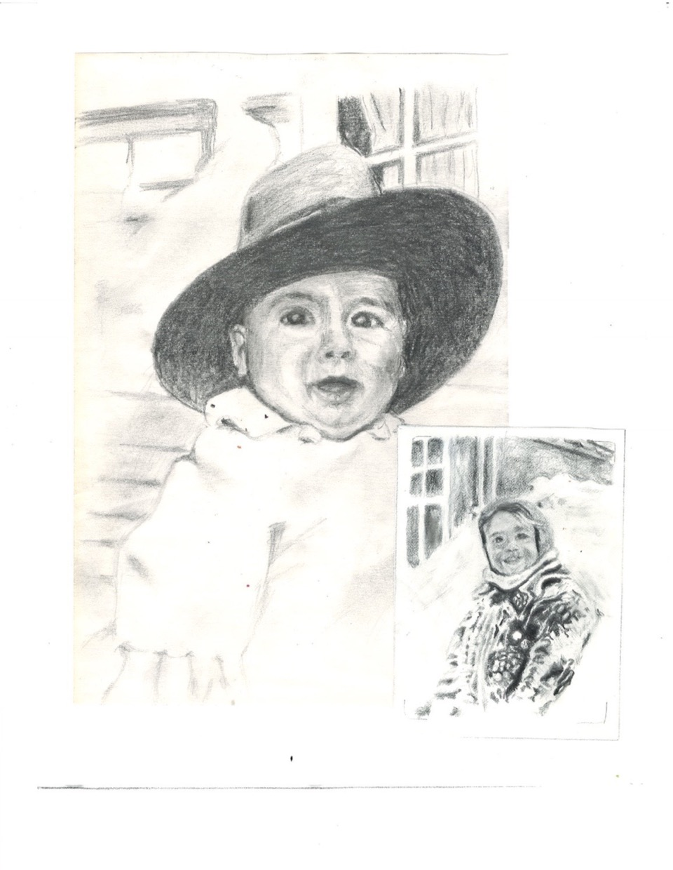

FRANK Pencil on paper, 8 x 10 inches, (Inset) Ink on paper, 3 x 5 inches

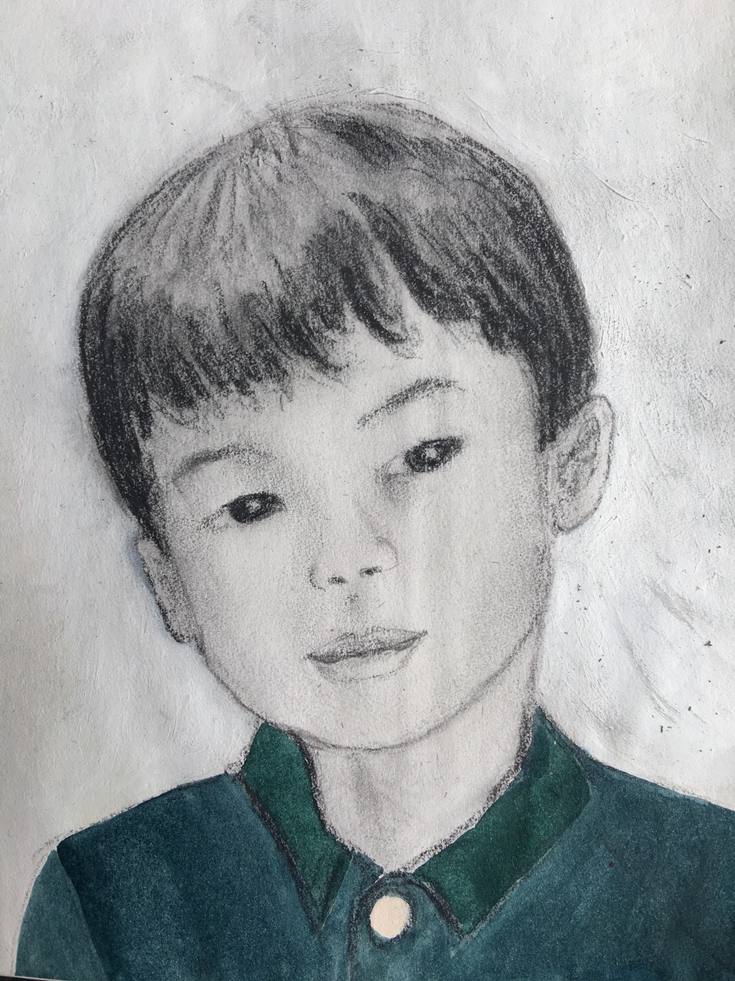

PETER Pencil on paper, 6 x 8 inches

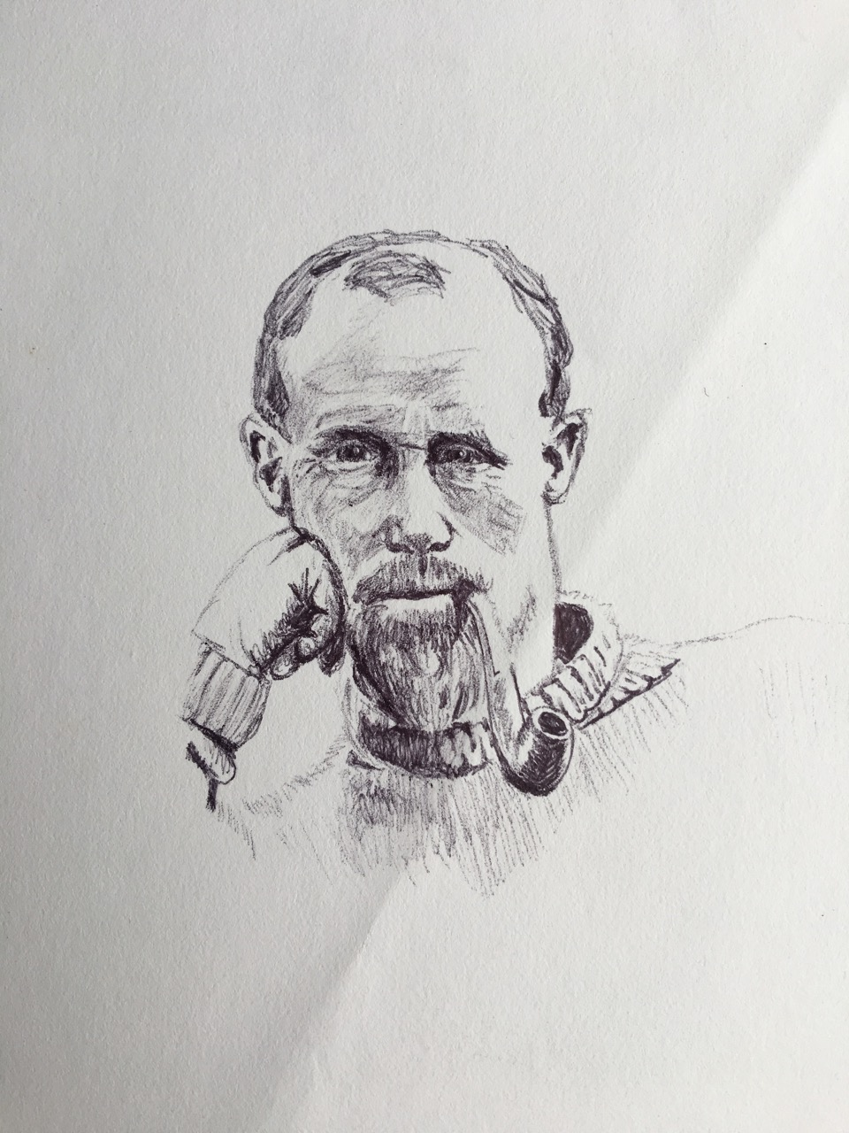

ENDURANCE CREW MEMBER Ink on paper, 3 x 5

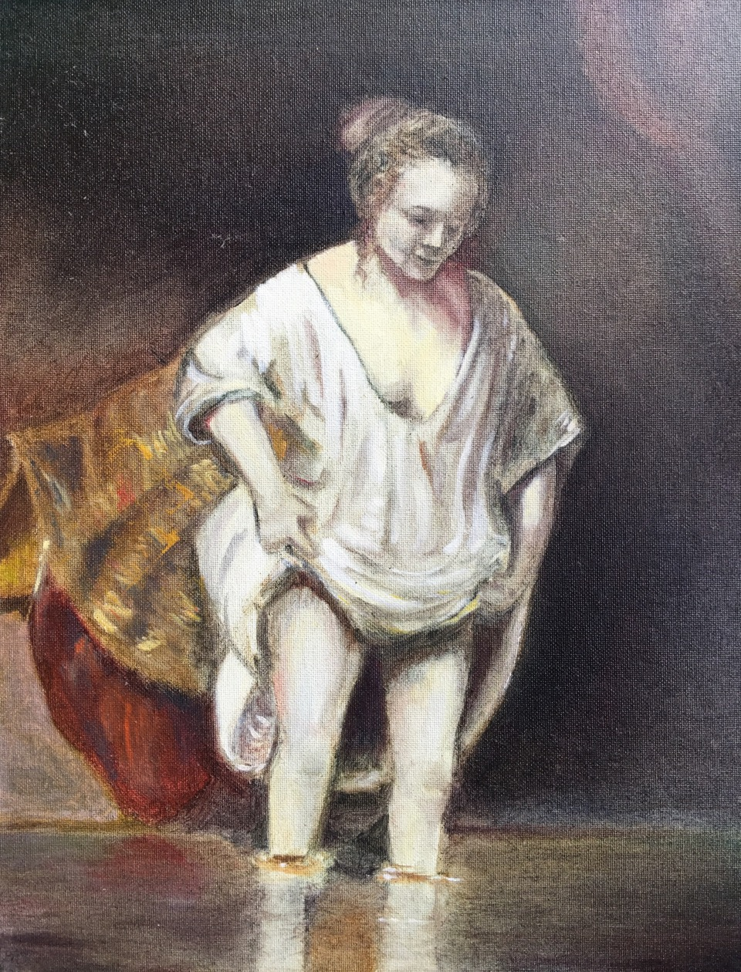

BATH Oil on canvas, 12 x 18 inches



ZAPOTEC MARKET Acrylic on paper, 8 x 10 inches

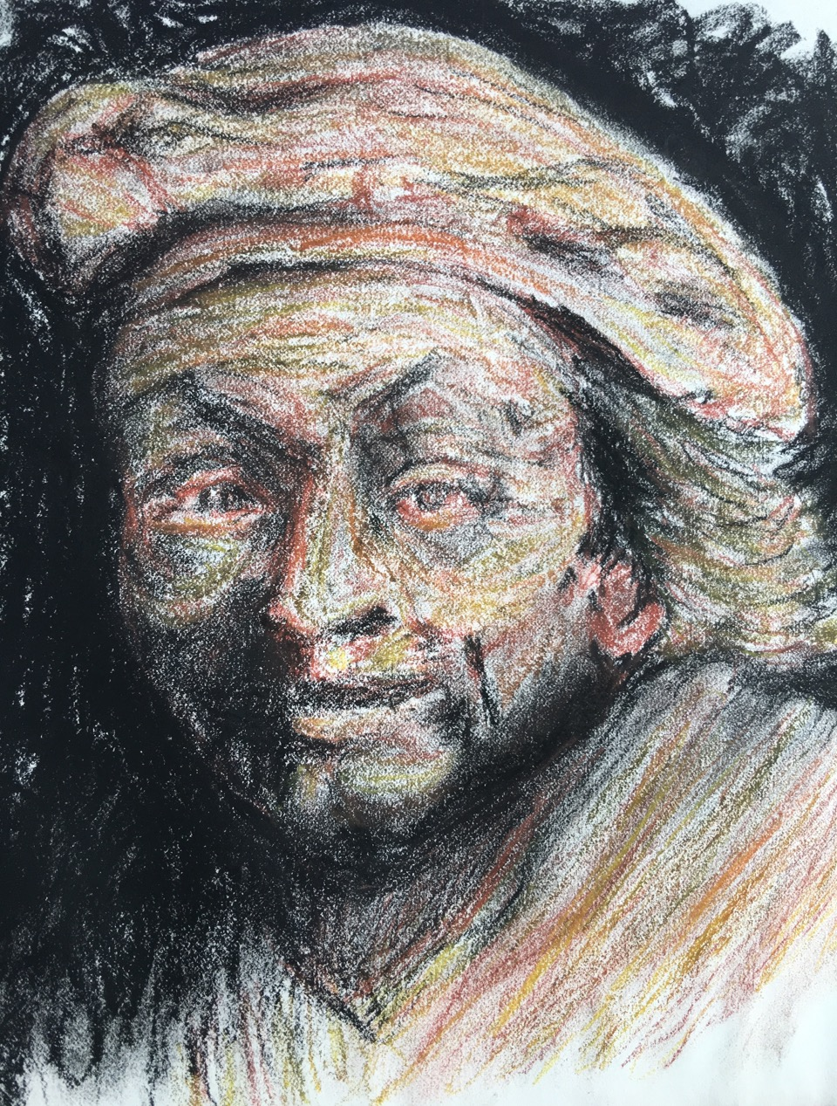

REMBRANDT Pastel on paper, 8 x 10 inches